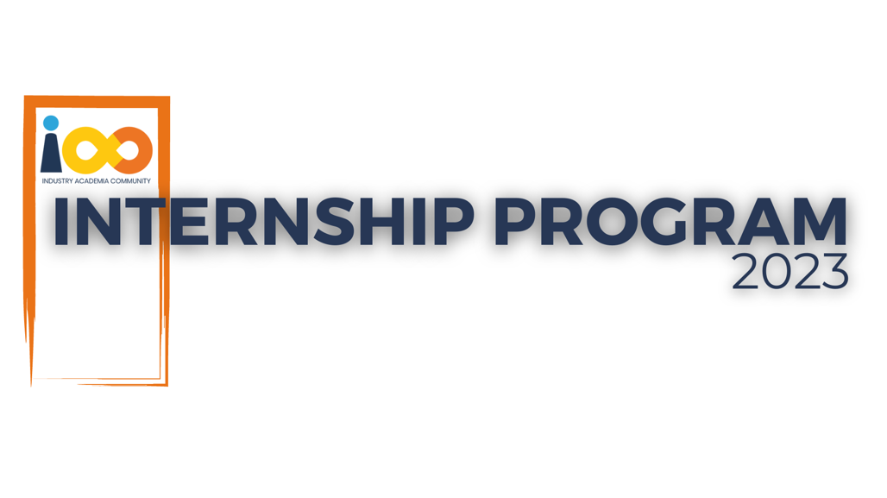

INSTALLATION AND OPERATIONS GUIDE

WEB DEVELOPMENT   
  
COURSECONNECT

|  |  |  |  |
| --- | --- | --- | --- |
| **Created By:** | Nidhi Krishna Pednekar | **Approved By:** | <Domain Lead Name> |
| **Created On:** | DD-MMM-YYYY | **Approved On:** | DD-MMM-YYYY |
|  |  |  |  |

**Table of Contents**

1. Introduction
2. System Requirements
3. Installation
   * Prerequisites
   * Installation Steps
4. Configuration
5. Operation Instructions
6. Troubleshooting
7. Maintenance

### **1. Introduction**

CourseConnect is a web application designed to provide information about colleges and courses. This guide will help you install, configure, and operate the CourseConnect application.

### **2. System Requirements**

#### **Hardware Requirements**

* Processor: Dual-core CPU
* RAM: 4 GB minimum
* Hard Disk: 10 GB of free space

#### **Software Requirements**

* Operating System: Windows 10/MacOS/Linux
* Node.js: Version 14.x or later
* MySQL: Version 8.0 or later
* XAMPP: Version 8.0 or later (for local development)

### **3. Installation**

#### **Prerequisites**

Before installing CourseConnect, ensure you have the following installed:

* Node.js
* MySQL
* XAMPP (for local server)
* Git

#### **Installation Steps**

1. **Clone the repository:**

git clone https://github.com/NidhiPednekar/CourseConnect.git

cd CourseConnect

1. **Install dependencies:**

npm install

1. **Set up the database:**

* Open XAMPP and start the Apache and MySQL services.
* Open phpMyAdmin and create a new database called College.
* Import the database schema from database file located in the repository.

1. **Configure environment variables:**

Create a .env file in the root directory and add the following variables:

DB_HOST=localhost ,

DB_USER=root ,

DB_PASSWORD=””,

DB_NAME=’College’ ,

PORT=3005

1. **Start the server:**

npm start

**4. Configuration**

• **Database Configuration:** Ensure the .env file has the correct database connection details.

• **Server Configuration:** Modify the server.js file if you need to change the server settings such as the port number.

### **5. Operation Instructions**

* **Accessing the Application:** Open a web browser and go to http://localhost:3005.
* **Using the Search Bar:**
  + Enter the name of a college or course in the search bar and press Enter.
  + Results will display relevant information about the searched college or course.

### **6. Troubleshooting**

* **Server not starting:**
  + Ensure Node.js is installed and the version is correct.
  + Check if the MySQL service is running.
  + Verify the database connection details in the .env file.
* **Database connection issues:**
  + Ensure the MySQL server is running.
  + Verify the database name, user, and password in the .env file.
* **Application not loading:**
  + Check for any errors in the browser's console.
  + Look at the terminal output where the server is running for any error messages.

### **7. Maintenance**

* **Updating the Application:**
  + - Pull the latest changes from the repository:

git pull origin main

* Install any new dependencies:

Npm install

* Restart the server:

Npm start

• **Database Backup:**

* Regularly backup the database using phpMyAdmin or command line tools.

• **Log Monitoring:**

* Regularly check the logs for any issues:
  + logs/error.log
  + logs/access.log